[Residential Controls](https://www.achrnews.com/topics/2705-residential-controls)[Services, Apps & Software](https://www.achrnews.com/topics/2716-services-apps-software)[Thermostats](https://www.achrnews.com/topics/2706-thermostats)[Apps & Software](https://www.achrnews.com/topics/2719-apps-software)

Ten Things HVAC Contractors Can Do Today to Get Started in the Smart Home Market

Want to get smart? Here's how …

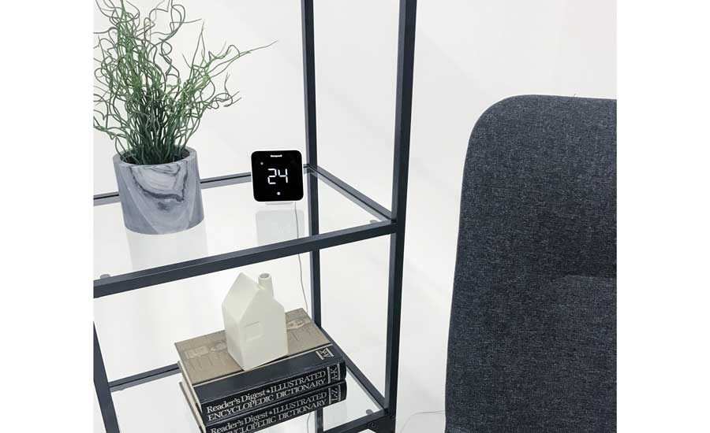

GET SMART: Connected systems, like Resideo’s D6 mini-split controller, offer convenience and efficiency for homeowners and contractors alike.

HVAC contractors and their employees visit dozens, maybe even hundreds or thousands of homes a week. They come into contact with countless doorbells, light switches, and home appliances. They’re trusted advisors to the customers in their care. So when the time comes for their customers to replace those doorbells with their [smart home](https://www.achrnews.com/keywords/14688-smart-homes) counterparts, shouldn’t HVAC contractors be the “smartest” choice for the job?

Here are 10 things HVAC contractors can do right away to make sure their companies are on track to start reaping the rewards of the burgeoning smart home business.

1. Start with what you know.

“If we’re talking specifically to HVAC contractors, the natural place to start is the thermostat,” said Gene LaNois, head of pro channel, Nest. “It’s not a big leap for them; they do this every single day. They can get comfortable in the brand power, in the technology.”

It also helps that thermostats are the most common smart home product that homeowners ask for.

“Thermostats are right at the top of the list — up there with cameras,” said AJ Smith, vice president and general manager, Global Pro Comfort, Resideo. “And it’s an area contractors are already comfortable with, from an electromechanical perspective. They don’t have to learn the ins and outs of how thermostats work: only the connected part of that.”

2. Take logical steps.

Got the smart thermostat under your belt and looking to expand services?

For HVAC contractors, moving into smart home products that provide safety and CO detection just makes sense, LaNois said.

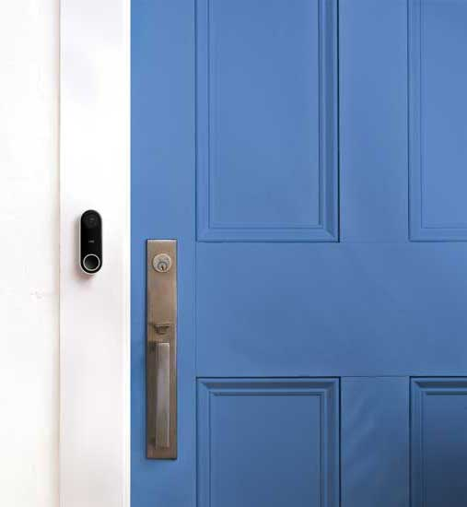

DING DONG, HVAC CALLING: “If you‘ve got a contractor who’s in for the thermostat, then for carbon monoxide detectors, then an Alexa product … the next one that’s very beneficial is the Nest Hello,” said Gene LaNois, head of pro channel, Nest. “It’s two wires and runs on 24V.”

“The ability to make sure they’re keeping customers safe, and [helping customers] have awareness of their home through their fingertips through the app, seems like a natural progression,” he said. “Nest Protect seems like a no-brainer for the HVAC contractor, especially in a business where we’re incorporating fossil fuel: natural gas, propane, boilers.”

From there, the smart doorbell is an incremental step up from what HVAC technicians do on a daily basis.

“If you‘ve got a contractor who’s in for the thermostat, then for carbon monoxide detectors, then an Alexa product … the next one that’s very beneficial is the Nest Hello [doorbell],” LaNois said. “It’s two wires and runs on 24V, the same voltage the [HVAC] industry uses. It’s a very simple wiring product for an HVAC contractor.”

Plus, think of how many doorbells get pressed by contractors on a daily basis — and how many they discover don’t work.

“They literally get the business opportunity through being at so many homes a day,” LaNois said.

3. Let staff try out the toys.

Manufacturers agree: The best way to get familiar with smart home products is to use them at home.

“Start with a full-blown system in your own home and in your sales and installers’ homes,” recommended George Land, general manager of connected home solutions for Ingersoll Rand. “Nothing beats speaking from personal experience and demoing your personal system to potential clients.”

LaNois takes a two-part approach.

“One is, introduce a training with your staff: their team, manufacturer reps’ teams, distribution partners,” he said. “I think it really starts off with introducing the products to the staff head-on.”

Once staff have a good feel for the products’ capabilities and features, they can be urged to purchase it through a discounted personal use program.

“We’re trying to make sure contractors have a tangible feel, because once they have it in their own home, they’re literally showing people what they can do off of their own system,” LaNois said. “That’s where we see the success rate go through the roof.”

4. Bundle up.

Contractors who are familiar with their brand’s suite of smart home products have the opportunity to sell more than one product at a time, if they can demonstrate the benefits of bundling.

“Obviously, there will always be some level of a budget that might drive some of that decision-making, but we believe, at a professionally installed level, a bundle or a kit usually happens in a consultated sale,” LaNois said. “If you tell the homeowners, ‘If you do get this thermostat, and you do have a gas furnace, and we put in the carbon monoxide alert, it will wirelessly shut off the furnace,’ you will have lots of consumers nodding their heads, understanding the benefit of that small bundle.”

The same applies to service for those products.

“Up-front, bundled service takes away objections to monthly fees and allows the contractor to participate in the service fees without excess monthly accounting headaches,” said Land.

Technology can also be packaged to target specific areas of a customer’s life.

“For example, a peace of mind package with water sensors for the condensate pan and the washing machine, or a comfort package with wireless temperature and humidity sensors for each bedroom,” Land said.

5. Share the knowledge.

Customers need to know how to work their new smart products.

“Entering the smart home market involves more than selling widgets,” Land said. “It involves being extremely knowledgeable about the connected platform that operates the widget, as well as the platform’s extensions: the website, smartphone or tablet app, and the customer service that goes with it. Once your team installs the connected products, you should encourage them to spend time with the homeowner, explaining the functionalities and app management. This is critical because once your team leaves the home, the homeowner will be on their own, and you want to make sure they are comfortable with using the platform and enjoy the experience.”

6. Understand your assets.

Professional contractors have (at least) one thing that Amazon, Lowe’s, or a do-it-yourself (DIY) YouTube video can’t offer: experience.

“A lot of consumers look up to their HVAC professional to give advice on their product,” said Craig Rossman, president at White Rogers. “Certainly there [are] customers who like to do it themselves. But you still have a large number of customers looking for expertise. Whether you want to be a maintainer and touch base with the customer every once in a while or be a bit more progressive in adopting the technology, you will have that advantage to be involved in the purchase decision and have a revenue stream, as opposed to that one-click purchase.”

And then there’s understanding the value proposition that smart thermostats — and the contractors who install them — deliver.

“Our Sensi thermostats, through Energy Star certification, can save 23 percent on energy costs by adjusting the room temp or by remote access or geofencing,” Rossman said. “A contractor that understands that value proposition and can speak confidently to the consumer has an advantage.”

Smith called it the fine tuning.

“Even though it’s very possible to go and get a thermostat at a store and install it yourself, many times, even though you’re getting the basic functionality out of that, the contractors still know these systems so much better than anyone else,” he said. “You put heat pumps, mini splits into the mix, some people have boiler systems … and without that fine tuning, they don’t maximize the efficiency, they don’t maximize the comfort, so you’re not getting the full benefit out of that purchase.”

7. Identify yourself.

You took the plunge into smart home. Now, it’s time to tell the world — or, more specifically, potential customers.

“The biggest thing we try to encourage contractors to do is make sure they’re identifying themselves as being in this business,” said LaNois. “HVAC contractors very clearly identify themselves as being in the heating and cooling business. But identifying themselves as being in the smart and connected home business is just as important.”

Otherwise, most consumers aren’t going to put two and two together.

“We have a lot of contractors who wrap their vans, put a Nest thermostat on the side,” LaNois said. “That’s great … it’s one piece.”

He pointed to American Residential Services as an example of claiming the smart home territory.

“If you go to their website, they’ve done that: They advertise heating, cooling, plumbing, smart home.”

8. Put it online.

Owning the wall starts with owning the market’s digital storefront.

“Have a price list, and feature the items you sell online,” said Lane. “The smart home category may look like a ‘do-it-yourself’ business, but the majority of homeowners want someone they know and trust to deliver and install the product they buy. It’s your customer … own the connected home space.”

Rossman added a word of warning: “We are nearing a point in time with smart technology where, if a contractor doesn’t offer those options, they’re ultimately going to get pushed out by the consumer in favor of one who does.”

Listing these services online is an easy way to plant your company flag in the smart home terrain.

9. Try selling peace of mind.

While it’s easy to get carried away talking about the latest and greatest gadgets, Smith suggested focusing on the products’ practical side instead.

“The really good connected offerings provide real, tangible benefits, beyond just being fun,” Smith said — whether it’s protecting a homeowner’s equipment, lowering their energy bill, or just saving them the hassle of hunting all over the house for a remote control to turn up the heat.

“So many things operate in conjunction with each other: Maybe one system is doing humidity, the other is doing heating,” Smith said. “[Connected systems] allow contractors to help the systems to really work together and be more efficient.

“One of our newest offerings, the mini-split D6 controller, offers benefits to the contractor as well as the homeowner,” he continued. “Those mini splits are installed usually at those top areas of the walls. Oftentimes, [a contractor] had to get a ladder out, get up to the unit itself to add on modules, etc. Our D6 mini-split controller gives the contractor the ability to add features and functions without having to go up to the unit itself.”

That might include a temperature sensor, which would allow sensing from a tabletop, at the level of the home’s inhabitants as opposed to up by the ceiling.

Focusing on these kinds of benefits will also make it easier for staff who are selling the connected home, Smith said.

“They’re a very grounded group who are very accustomed to saying ‘No, that’s not necessary, not the right thing for you,’” he said. “They’re not going to put a lot of fluff or extra stuff in people’s homes. When owners focus on the energy savings, comfort, the convenience of being able to monitor remotely … it will resonate with their staff as well, and it will be easier for [them] to go out and market those benefits.”

10. Like the Boy Scouts, be prepared.

“Once you install a basic smart home package for your customer, they will most likely want you to integrate more smart home products to create a full connected experience,” said Lane.

Contractors who want to take advantage of that return business should familiarize themselves and their team members with smart home products that fall outside the scope of the thermostat and other HVAC devices, so they can continue providing thoughtful recommendations that would best meet their customers’ comfort and budget needs.

From：https://www.achrnews.com/articles/140225-ten-things-hvac-contractors-can-do-today-to-get-started-in-the-smart-home-market